Task 1: Player UI
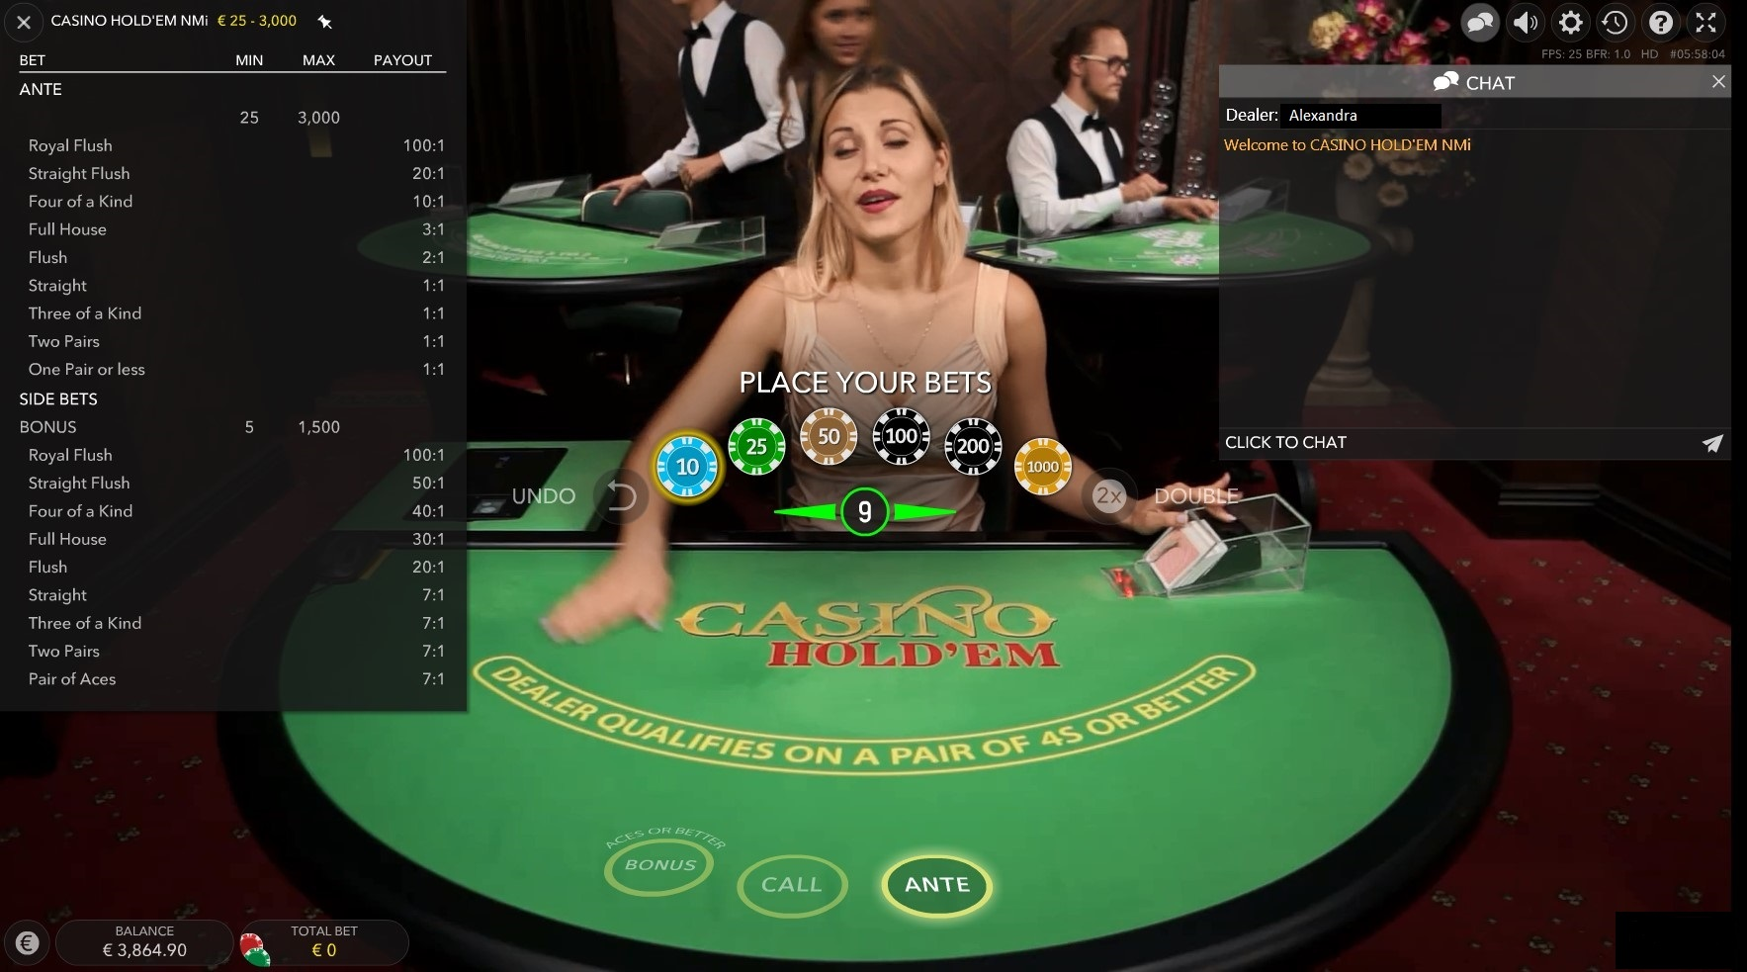

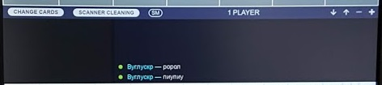 [Dealer chat]

How would you address chat testing taking into the account the following information:
- Players within chat with multiple operators (casinos) have an access to the same table.
- Dealer sees messages sent by players.
List example of scenarios and explain your approach.

Test strategy: basically, we have 2 main parties: Users and Dealer so I divide scenarios into 2 groups, also we should consider combinations for users within chat with different casinos.
Test scenarios for Dealer:
- Verify Dealer can see and reply to messages within chat with single user from Casino 1.
- Verify Dealer can see and reply to messages within chat with multiple users from Casino 1.
- Verify Dealer can see and reply to messages within chat with single from Casino 1 and single user from Casino 2.
- Verify Dealer can see and reply to messages within chat with single user from Casino 1 and multiple users from Casino 2.
- Verify Dealer can see and reply to messages within chat with multiple users from Casino 1 and multiple users from Casino 2.
- Verify dealer have access to chat history after disconnecting.

Test scenarios for Users:
- Verify User can see and reply to messages within chat with single user from Casino 1.
- Verify User can see and reply to messages within chat with multiple users from Casino 1.
- Verify User can see and reply to messages within chat with single from Casino 1 and single user from Casino 2.
- Verify User can see and reply to messages within chat with single user from Casino 1 and multiple users from Casino 2.
- Verify User can see and reply to messages within chat with multiple users from Casino 1 and multiple users from Casino 2.
- Verify user have access to chat history after disconnecting

Task 2: Static testing. Please review specification below and point our error/mistake (if any) found.

The objective in Baccarat is to predict whose hand will win by having the value closest to 9.

The dealer begins by dealing two cards each to the Player and to the Banker.
Two hands are dealt in Baccarat: one hand to the Player and one hand to the Banker.

If the Player and Banker hold hands of equal value, the round ends in a tie. The Tie bet wins, and bets on the Player and Banker push (are returned).
Each hand's value is calculated by dropping the tens digit in a hand otherwise worth 11 or more. For example, a 7 and a 9 is only worth 6 in Baccarat (because 16-10=6). Similarly, a face card plus a 9 will be worth 9.

If the Player or the Banker receives an initial two-card hand worth 8 or a 9 (a "natural" 8 or 9), no additional cards will be dealt to either hand.
If the Player and Banker receive initial two-card hands worth 0-7, the "Third Card Rule" is consulted to determine if a third card is to be dealt to either hand or both hands. The Player always goes first.

Pairs Button
When user taps the PAIRS button - two additional betting spots are added (PLAYER PAIR and BANKER PAIR).
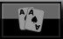


It is allowed to bet only one Pairs betting spot at the same time. If user tries to place the bet on both Pairs spots at the same time - second bet is accepted too and message "bet restrictions apply" is displayed for the user.
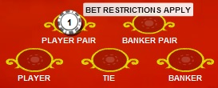
To win the bet on "Player Pair", the first 2 cards dealt to Player must be a pair, to win the bet on "Banker Pair", first 2 cards dealt to Banker could be any.

